

World Over Group Database System

Software Requirement Specifications

**Project Advisor:**

Lehmia Kiran

**Group Members:**

Ali Latif 19L-1018

Shahveer Ahmad 19L-2243

Abdul Rehman 19L-1135

Umer Farooq 19L-1189

Table of Contents

1. Introduction 3

1.1 Purpose 3

1.2 Scope 3

1.3 Definitions, Acronyms, and Abbreviations 3

2. Overall Description 4

3. Functional and Non Functional Requirements 4

3.1 Functionality 4

3.1.1 Add data. 4

3.1.2 Get Data. 4

3.1.3 Send Data. 5

3.1.4 Provide Search facility. 5

3.1.5 Maintain custom notifications. 5

3.1.6 Maintain user profile. 5

3.2 Usability 6

3.2.1 Graphical User Interface 6

3.2.2 Accessibility 6

3.3 Reliability 6

3.4 Performance 6

3.5 Data Storage 6

4. DataFlow Diagram Level 0

4.1 DFD Level 1 7

4.2 DFD Level 2 8

5. Hardware/Software Requirement 8

5.1 Hardware Requirements 8

5.2 Software Requirements 8

Software Requirements Specification

# 

# Introduction

The purpose of this document is to gather and analyze and give an in-depth insight of the complete **World Over Group Database System** by defining the problem statement in detail.

## Purpose

The purpose of the document is to collect and analyze all assorted ideas that have come up to define the system. Also, we shall predict and sort out how we hope this product will be used in order to gain a better understanding of the project, outline concepts that may be developed later, and document ideas that are being considered, but may be discarded as the product develops.

In short, the purpose of this SRS document is to provide a detailed overview of our software product, its parameters and goals. This document describes the project's target audience and its user interface, hardware and software requirements. It defines how our client, team and audience see the product and its functionality.

## Intended Audience

The intended audience for the world over group database system will be all the working members in the world over group company. Basically it will have different restrictions for each user which is using it. For example a normal worker in the company cannot  add or edit data without required permissions. He can only see and analyse data and send notification mails.

## Definitions, Acronyms, and Abbreviations

|  |  |
| --- | --- |
| WOG | World Over Group |
| FAQ | Frequently Asked Questions |

# Overall Description

This document contains the problem statement that the current system is facing which is hampering the growth opportunities of the company. WOG is a marketing company in Faisalabad. Employees get data using scrapers and then use their marketing techniques to sell the products. Currently at WOG all employees are storing data in excel files and then the manager checks all the files, assigns unique numbers and adds that data in a combined excel file. It takes a lot of time while adding and compiling. Also they need to check which data have some missing attributes in it. After compiling data they assign data to each of their members in each country they also need to track manually which portion of data is assigned to which client. By using the new system all things will be automated they just need to input new data. They can also set different types of notifications. Moreover, this system will distribute data according to countries to different marketers in respective countries.

# 

# Functional and Non Functional Requirements

The specific requirements are –

## 

## Functionality

This subsection contains the requirements for the WOG database system.

### **Add data.**

#### The system shall allow the user to add data and support to file formats (comma separated and excel).

#### The system shall allow user to undo the add operation.

#### The system shall display all the data which is imported first in a dialog box before adding.

#### The system shall prompt before adding data to make sure.

#### The system shall automatically add data in respective database tables according to file headers.

#### The system shall prompt and make a new file of the data which contains missing information.

### **Get Data.**

#### The system shall allow the user to get data.

#### The system shall provide comma separated and excel file formats to get data.

#### The shall provide different filters to get data.

### **Send Data.**

#### The system shall allow the user to send data to other individuals using google mail.

#### The system shall allow user to send data to google sheets.

### **Provide Search facility.**

#### The system shall enable user to enter the search text on the screen.

#### The system shall enable user to apply different filters on the search.

#### The system shall enable user to select multiple options on the screen to search.

#### The system shall display all the matching products based on the search

#### The system shall display only 10 matching result on the current screen.

#### The system shall enable user to navigate between the search results.

#### The system shall notify the user when no matching data is found on the search.

### **Maintain custom notifications.**

#### The system shall enable user to set custom notifications according to his or her needs.

#### When the program starts it will notify the user according to notifications.

#### The system shall remind the user if some data needs to send to some person or to receive from someone.

### **Maintain customer profile.**

#### The system shall allow user to create profile and set his credential.

#### The system shall authenticate user credentials to view the profile.

#### The system shall allow user to update the profile information.

## Usability

### **Graphical User Interface**

#### The system shall provide a uniform look and feel between all the widgets.

#### The system shall also display images of companies if available.

#### The system shall also provide settings for light and dark mode.

### **Accessibility**

#### The system shall provide different data access levels.

### **Reliability**

#### The system shall also keep backup of all data which is stored.

#### The system also uploads all the data to google sheets as a secondary backup.

### **Performance**

#### The performance shall depend upon hardware components of the client/customer.

#### It will use multi-threading to get and upload data files.

### **Data Storage**

#### The system shall store all the data in sqlite database.

#### The sqlite database file shall be password protected.

1. **Data Flow Diagrams**

Level 0

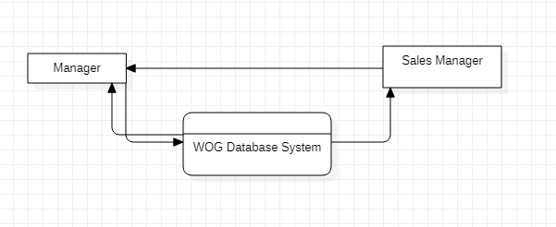

Level 1

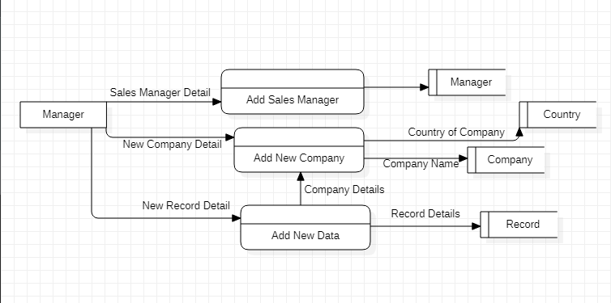

Level 2

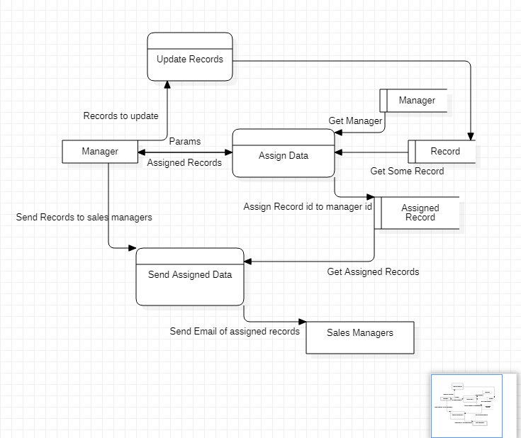

# Hardware/Software Requirements

The system shall be built using python 3.10 and PYQT-5.

# 5.1 Hardware

### The minimum RAM shall be 1GB.

### The minimum required space for this application shall be 200 Mb.

### Software speed will depend upon the client hardware specifications.

### Software shall be able to run number of threads according to the core of the clients PC.

## 5.2 Software

#### The system shall run on windows 8 or later version.

#### The recommended OS is windows 10.